How to login into your AWS Account and what can you do there

1. 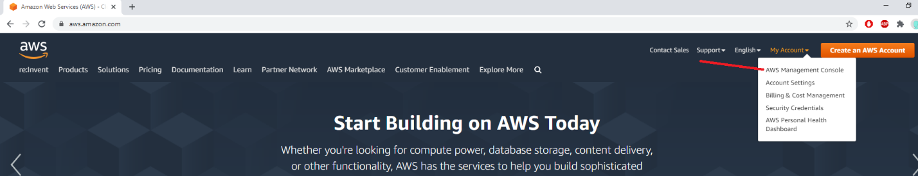Go to *aws.amazon.com* and go to **AWS Management Console.**
2. 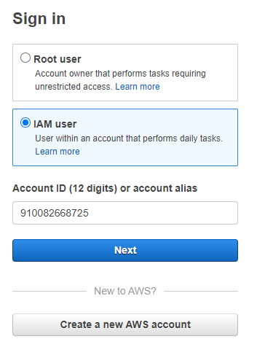Choose to login as **IAM User** and use 910082668725 **Account ID**. You don’t have access to root account.
3. Enter credentials that were given to you.

Congrats! You’ve successfully logged in into your IAM AWS Account!

**Note: Make sure you are using right region (Check top right corner of the webpage to change it) ! (In your case it should be Frankfurt)**

1. Press Services and go to EC2.
2. 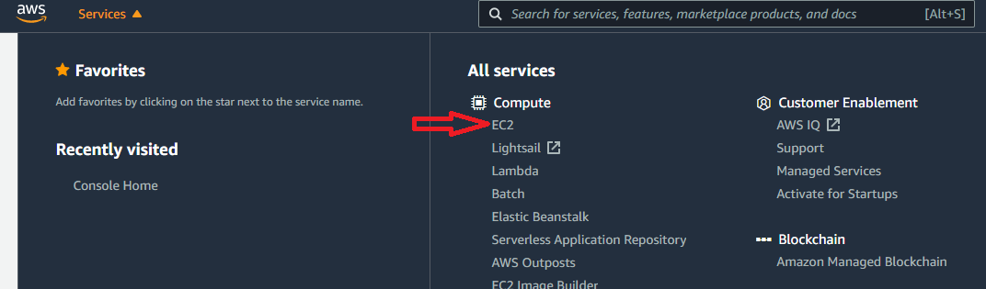Press Instances (on the left sidebar)
3. To Start, Stop or Reboot instances select the instance u want and change its state (check screenshot)
4. 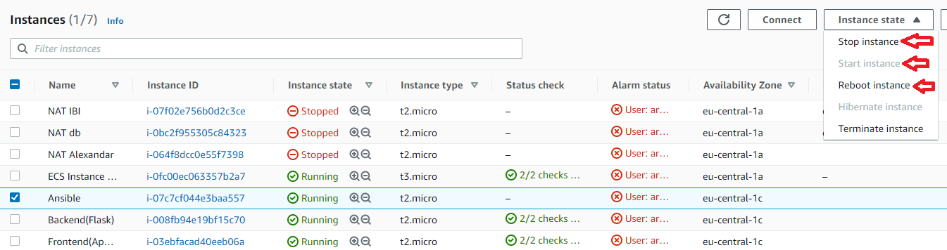Congrats! You know how to start, stop, and reboot instances now!

**Note: You will have restricted access. Even though, you will see all instances, but you will be able to interact with the ones that you have access to. (Instances that you have access to have your or name of your group on it)**

**Note: You will see API Errors on some screens. That’s normal since you have limited permissions.**